Some pictures of how I made the prototype box

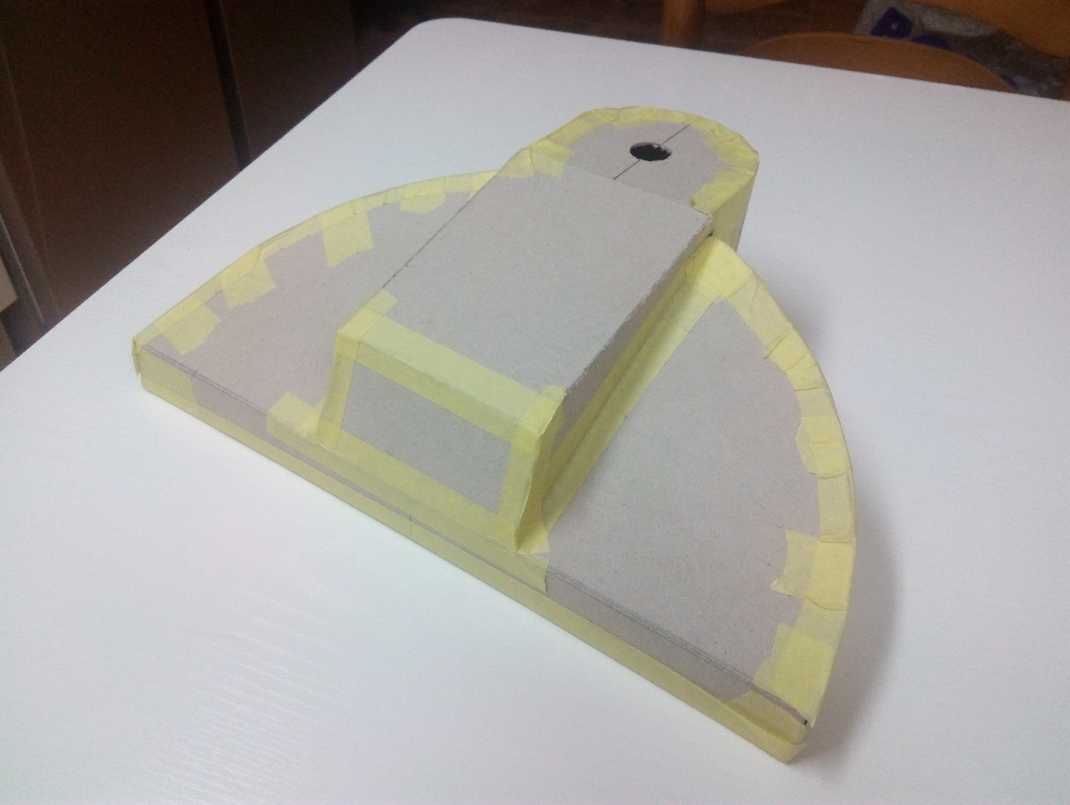

But it is not chosen. I prefer this: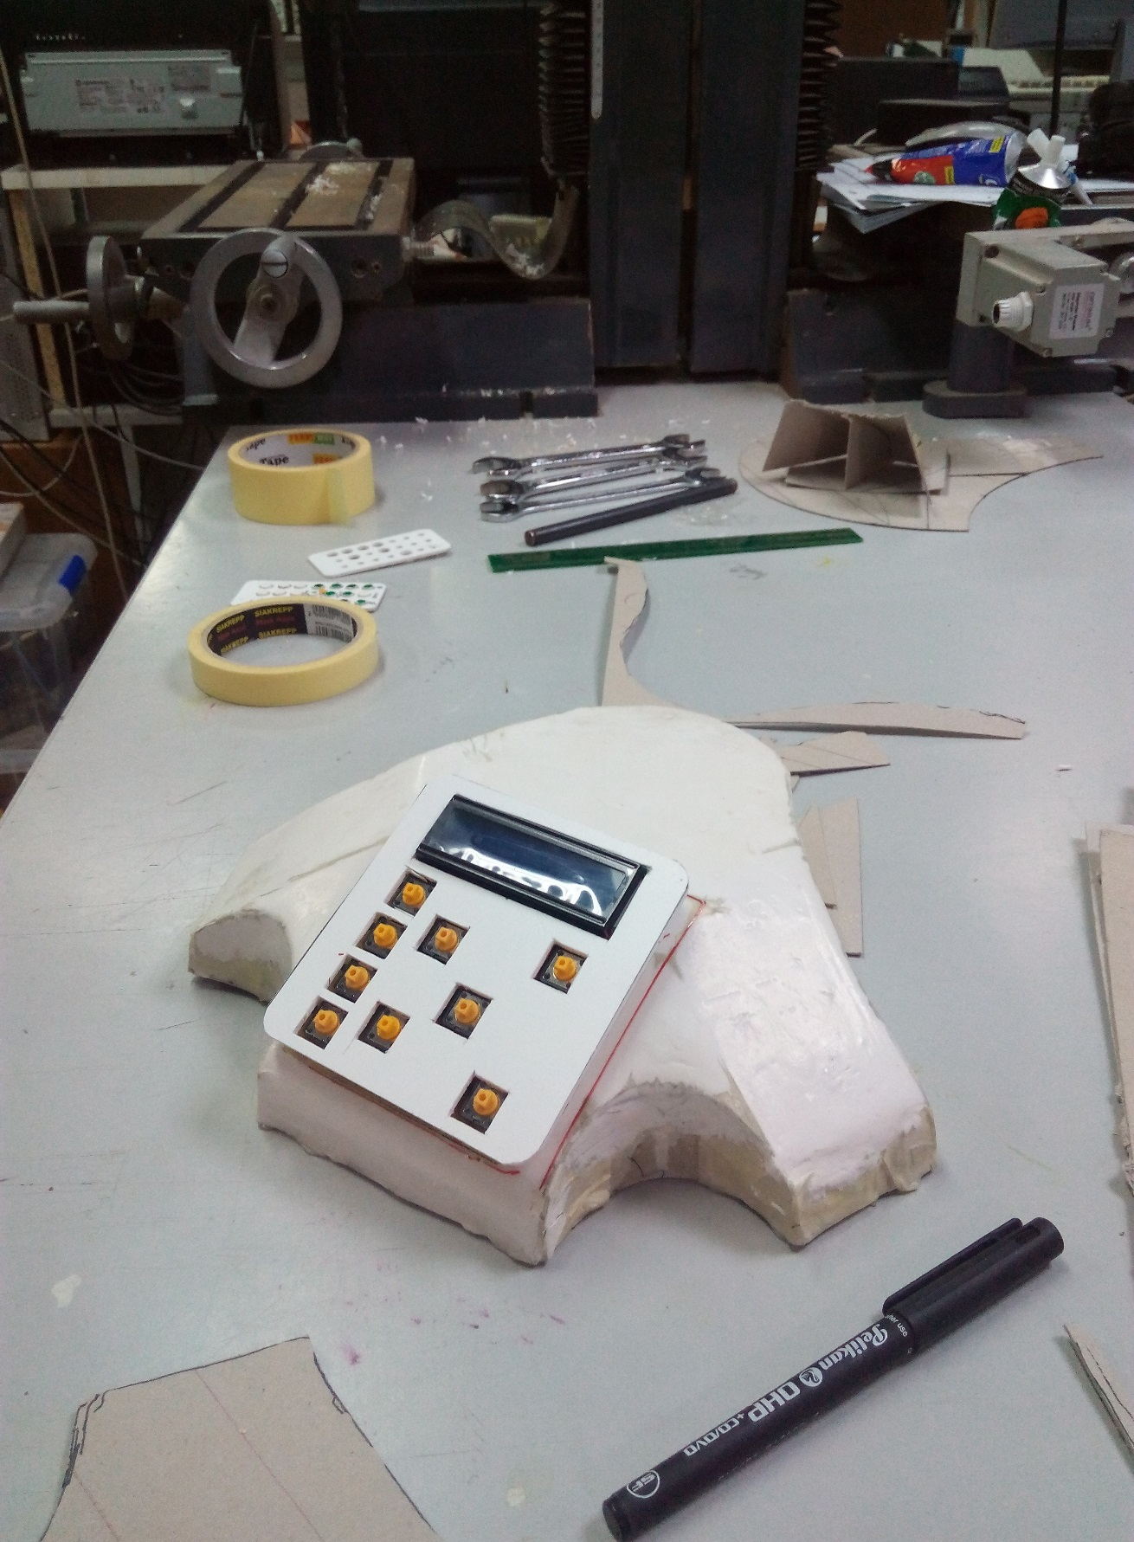

They are made with a technique that I developed using a cardboard structure and duct tape which provides the basis for applying resin and fiberglass to harden.

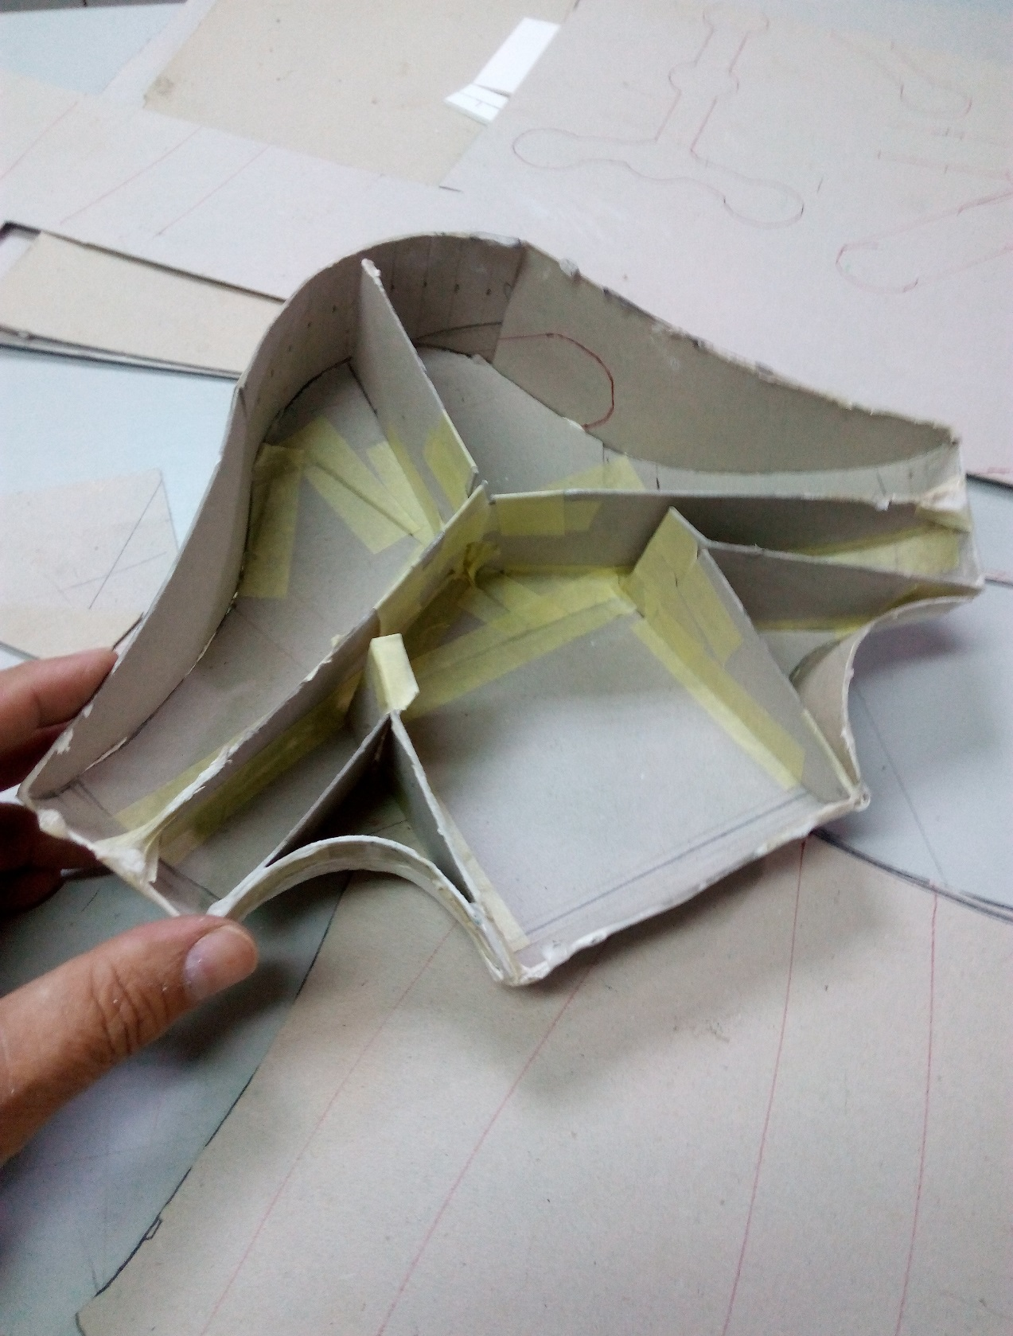

Before applying the resin and fiberglass walls are smoothed with polyester putty

After the interior structure is empty. This structure supports the walls while building

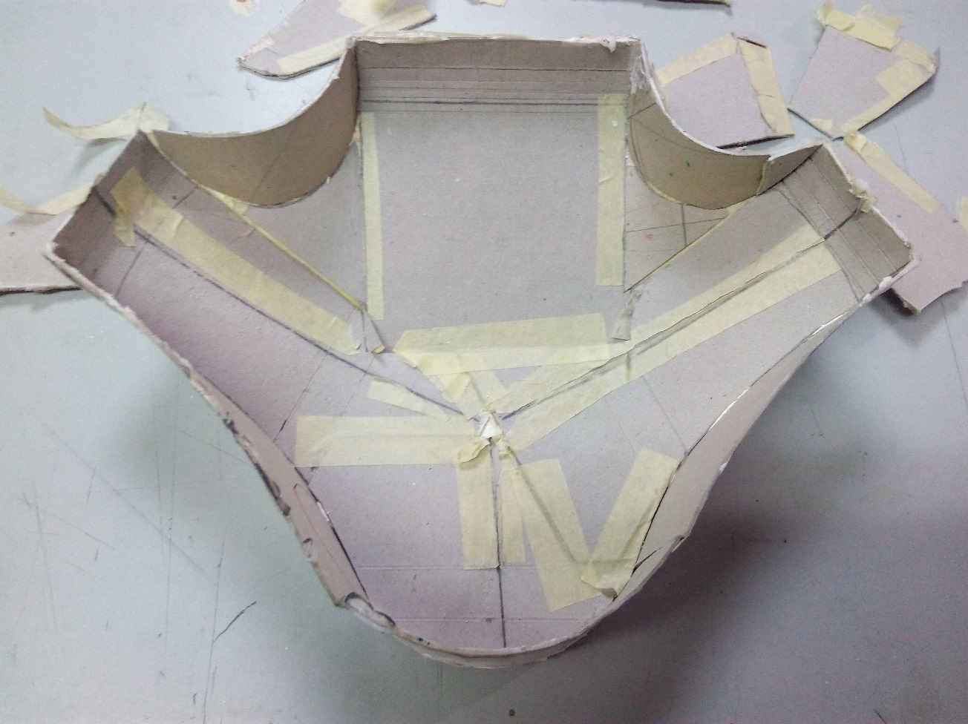

building the base of the box

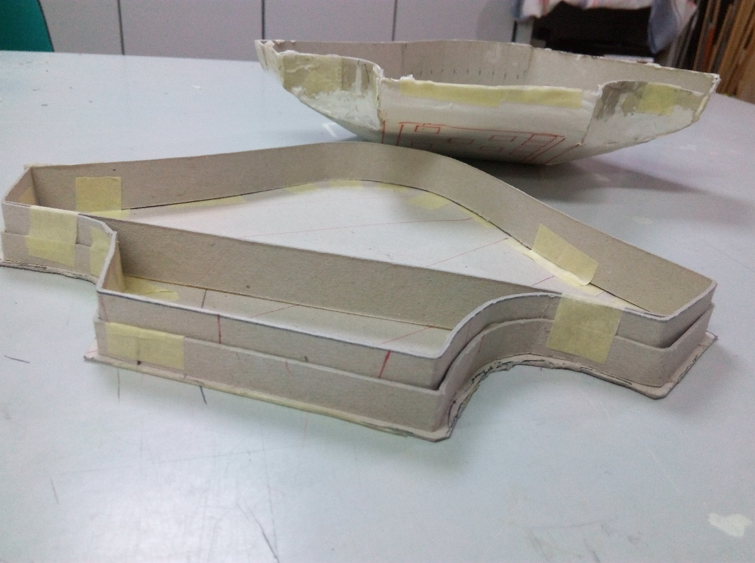

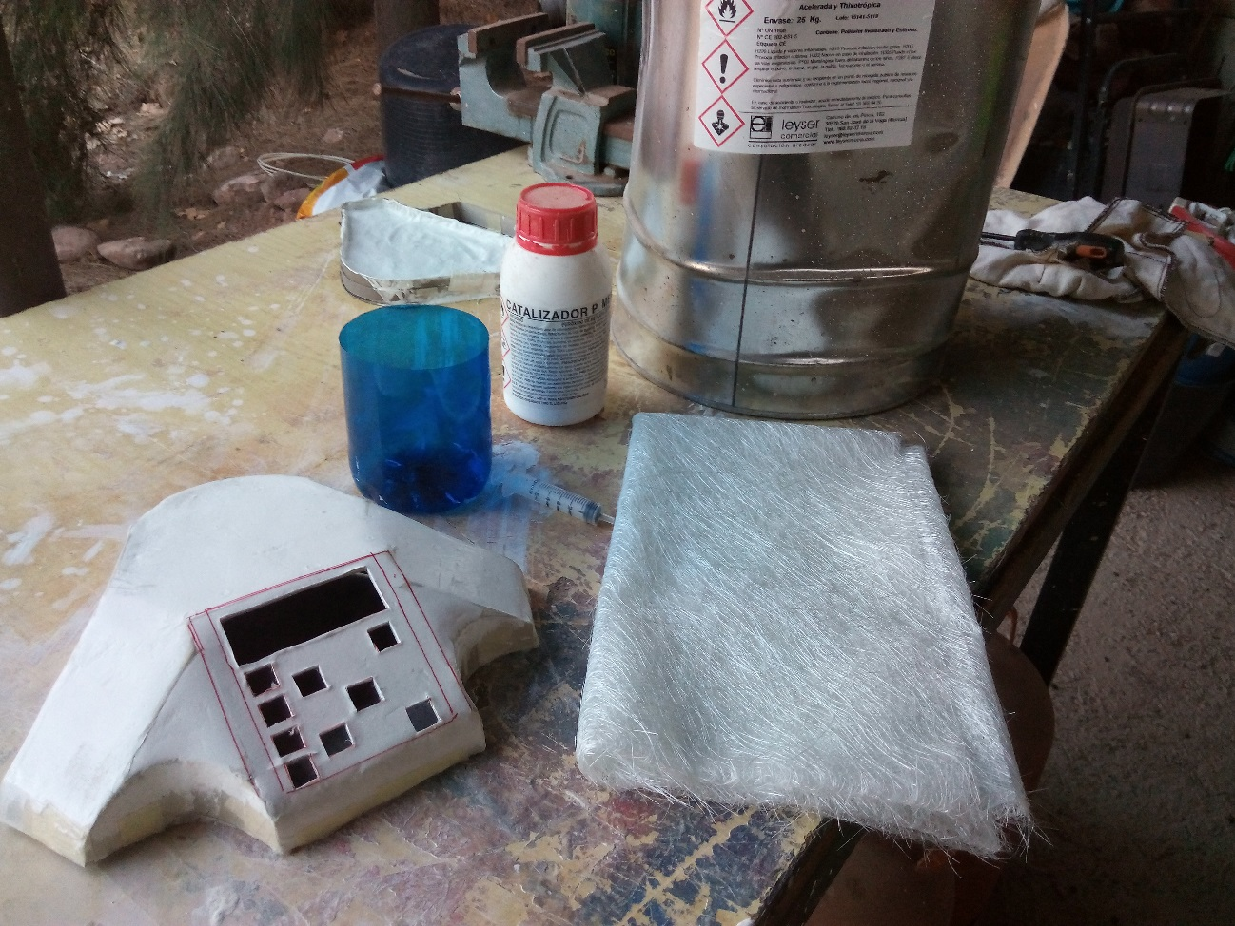

starting to work with polyesther resine and fiber glass